Secant
# Source: AI Source: Provided by: [Data Path: Persons Table -> ID Column: 1, Name_En Column: Motasem Essam] -> From: [ChatGPT] on [7/25/2026]
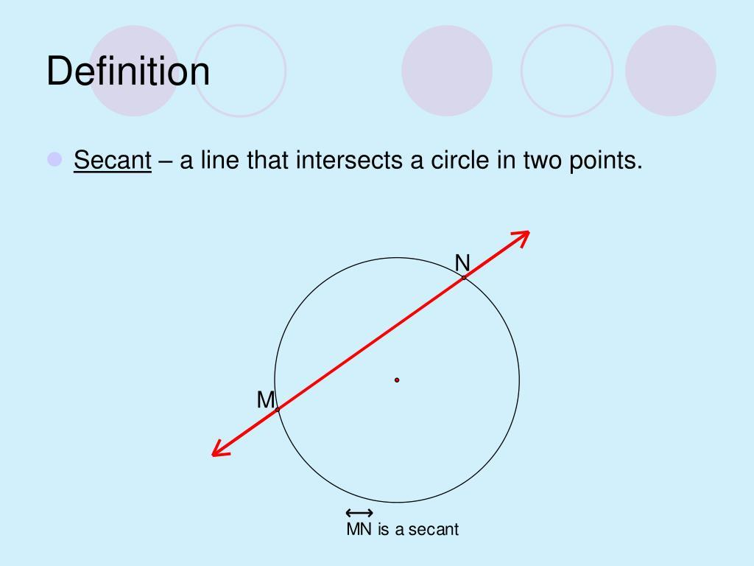
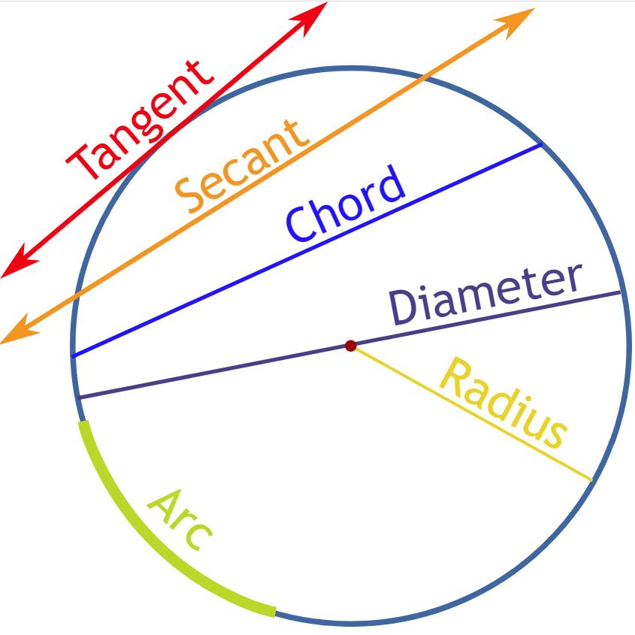
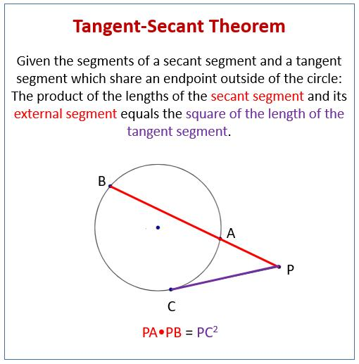
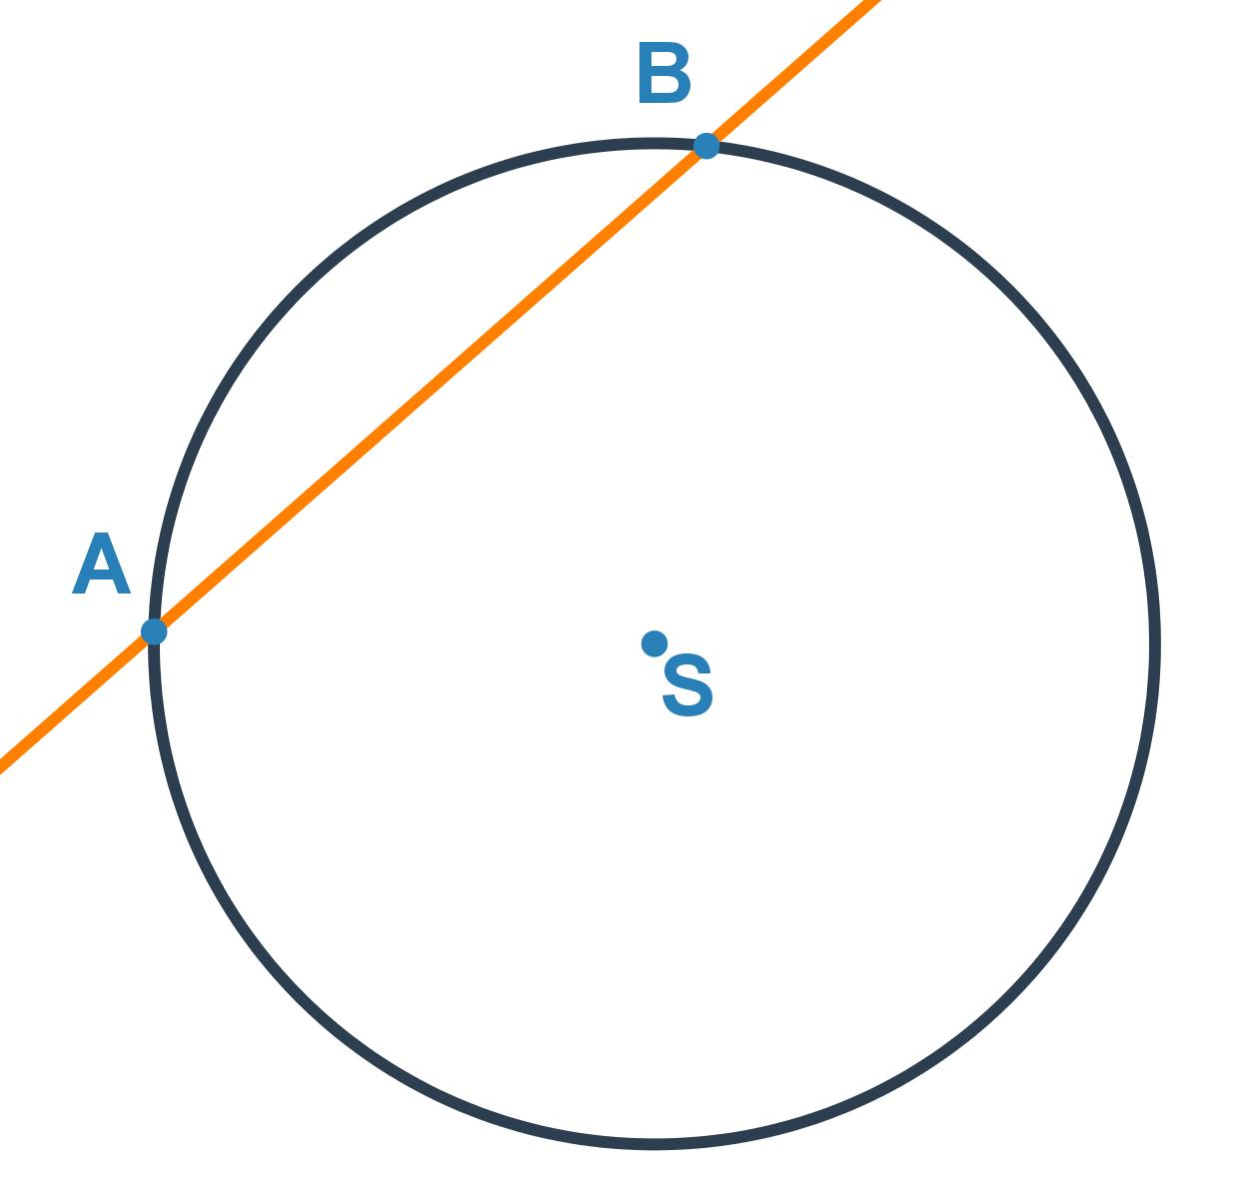
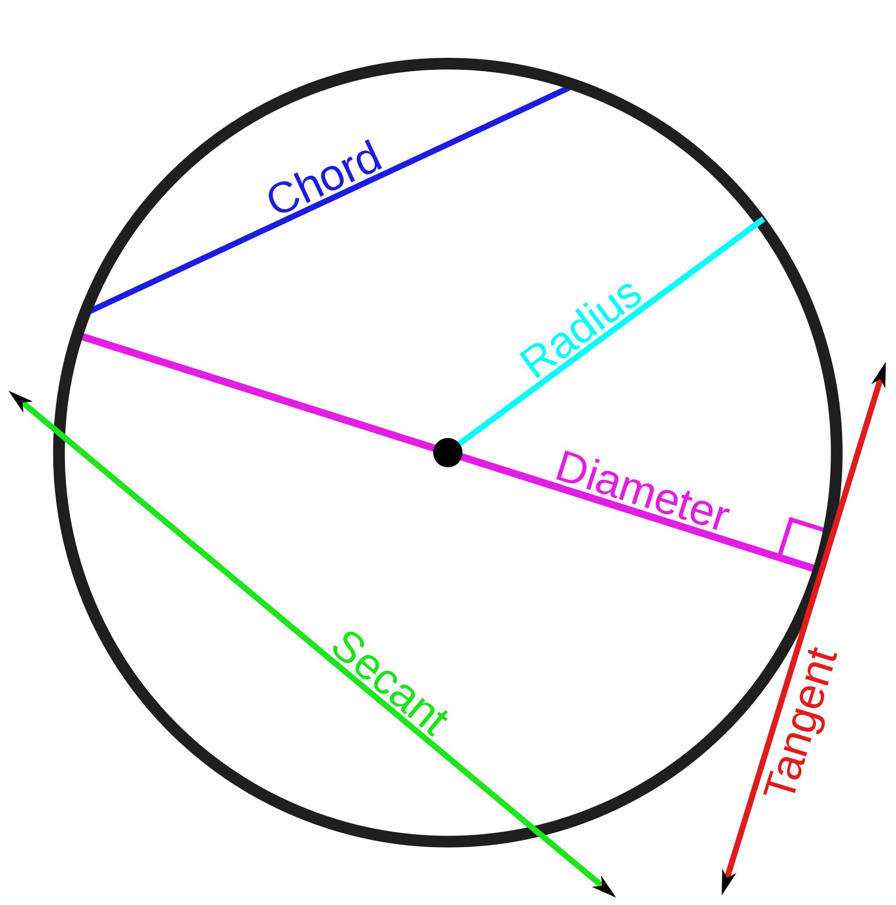

Definition
# Source: AI Source: Provided by: [Data Path: Persons Table -> ID Column: 1, Name_En Column: Motasem Essam] -> From: [ChatGPT] on [7/25/2026]
A Secant is a line that intersects a circle at two distinct points.
The two points where the secant intersects the circle are called the points of intersection.
If a line $l$intersects a circle at points $A$and $B$, then $l$is a secant of the circle.

Fundamental Concept
# Source: AI Source: Provided by: [Data Path: Persons Table -> ID Column: 1, Name_En Column: Motasem Essam] -> From: [ChatGPT] on [7/25/2026]
Consider a circle with center $O$and a secant line:
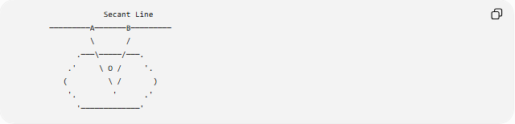
Secant Line
─────────A───────B─────────
\ /
.───\─────/───.
.' \ O / '.
( \ / )
'. ' .'
'─────────────'
Here:
- $A$and $B$= points where the secant intersects the circle
- $\overset{‾}{AB}$= chord created inside the circle
- The entire line = secant
A key distinction is:
$$\boxed{\text{Secant = entire line}}$$
while:
$$\boxed{\text{Chord = segment between the two intersection points}}$$

Main Parts
# Source: AI Source: Provided by: [Data Path: Persons Table -> ID Column: 1, Name_En Column: Motasem Essam] -> From: [ChatGPT] on [7/25/2026]
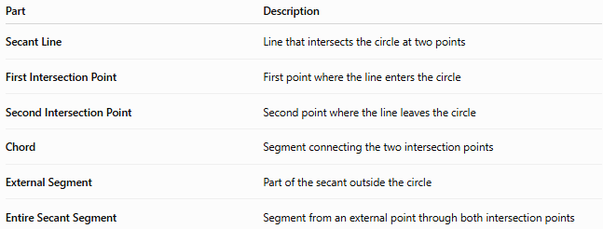
Part | Description
Secant Line | Line that intersects the circle at two points
First Intersection Point | First point where the line enters the circle
Second Intersection Point | Second point where the line leaves the circle
Chord | Segment connecting the two intersection points
External Segment | Part of the secant outside the circle
Entire Secant Segment | Segment from an external point through both intersection points

Secant and Circle
# Source: AI Source: Provided by: [Data Path: Persons Table -> ID Column: 1, Name_En Column: Motasem Essam] -> From: [ChatGPT] on [7/25/2026]
A line can have different relationships with a circle:
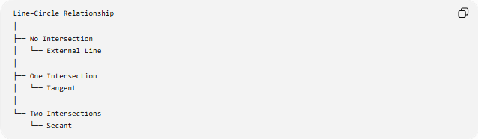
Line–Circle Relationship
│
├── No Intersection
│ └── External Line
│
├── One Intersection
│ └── Tangent
│
└── Two Intersections
└── Secant
Therefore:
- 0 points → external line
- 1 point → tangent
- 2 points → secant

Secant and Chord
# Source: AI Source: Provided by: [Data Path: Persons Table -> ID Column: 1, Name_En Column: Motasem Essam] -> From: [ChatGPT] on [7/25/2026]
A secant and a chord are closely related but are not the same.
A secant is a line extending indefinitely in both directions.
A chord is the finite segment connecting the two points where the secant intersects the circle.
Thus:
$$\boxed{\text{Chord}⊂\text{Secant Line}}$$
when the chord lies on the secant line.

Secant and Tangent
# Source: AI Source: Provided by: [Data Path: Persons Table -> ID Column: 1, Name_En Column: Motasem Essam] -> From: [ChatGPT] on [7/25/2026]
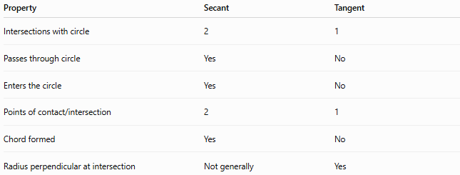
Property | Secant | Tangent
Intersections with circle | 2 | 1
Passes through circle | Yes | No
Enters the circle | Yes | No
Points of contact/intersection | 2 | 1
Chord formed | Yes | No
Radius perpendicular at intersection | Not generally | Yes
The tangent can be considered a limiting case of a secant when its two intersection points approach the same point.

External Secant
# Source: AI Source: Provided by: [Data Path: Persons Table -> ID Column: 1, Name_En Column: Motasem Essam] -> From: [ChatGPT] on [7/25/2026]
An External Secant is a secant line considered from an external point $P$.
Suppose the secant passes through the circle at $A$and $B$:
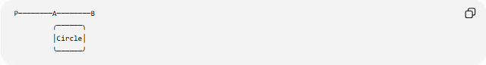
P────────A────────B
╭──────╮
│Circle│
╰──────╯
The relevant lengths are:
- $PA$= external secant segment
- $AB$= chord inside the circle
- $PB$= entire secant segment
Therefore:
$$\boxed{PB=PA+AB}$$

Secant–Secant Theorem
# Source: AI Source: Provided by: [Data Path: Persons Table -> ID Column: 1, Name_En Column: Motasem Essam] -> From: [ChatGPT] on [7/25/2026]
When two secants are drawn from the same external point $P$, their lengths satisfy:
$$\boxed{PA⋅PB=PC⋅PD}$$
where:
- $PA$= external part of first secant
- $PB$= entire first secant
- $PC$= external part of second secant
- $PD$= entire second secant
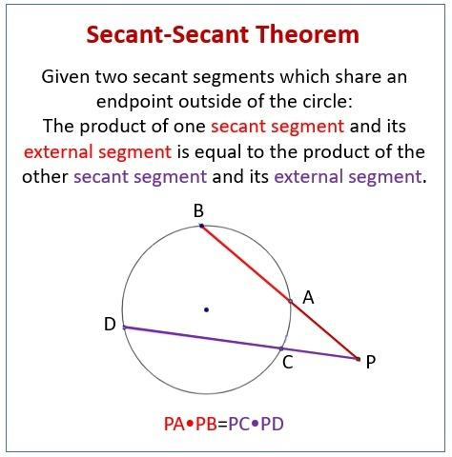
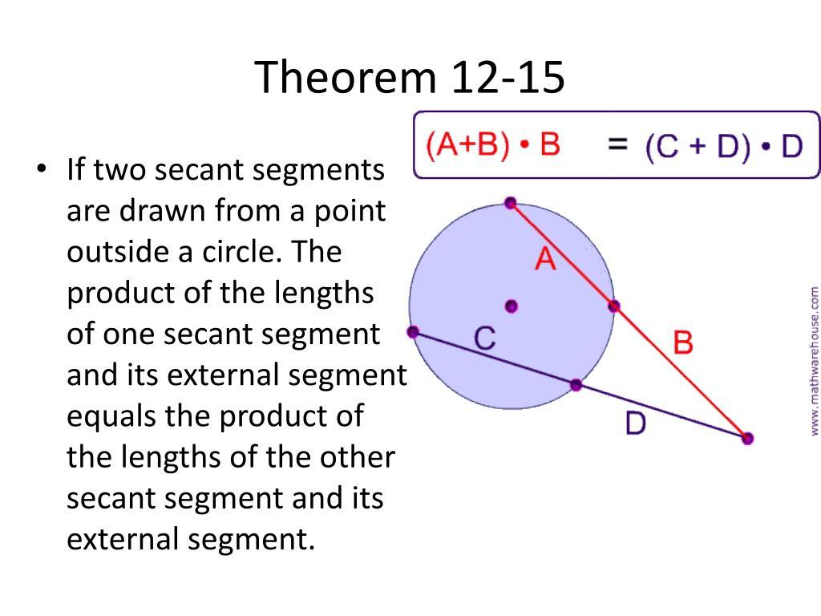
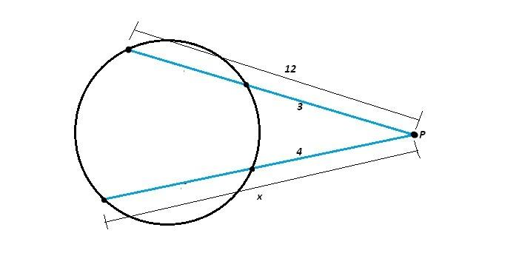
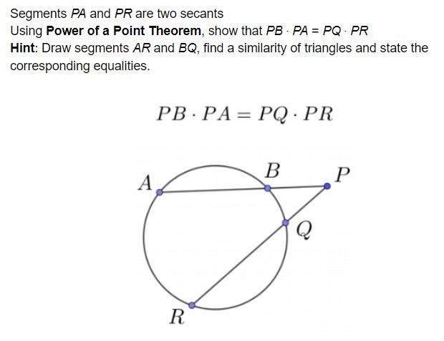

Example: Secant–Secant Theorem
# Source: AI Source: Provided by: [Data Path: Persons Table -> ID Column: 1, Name_En Column: Motasem Essam] -> From: [ChatGPT] on [7/25/2026]
Suppose:
$$PA=4 \\ PB=12$$
and:
$$PC=3$$
We want to find $PD$.
Using:
$$PA⋅PB=PC⋅PD \\ 4\left(12\right)=3\left(PD\right) \\ 48=3PD$$
Therefore:
$$\boxed{PD=16}$$

Tangent–Secant Theorem
# Source: AI Source: Provided by: [Data Path: Persons Table -> ID Column: 1, Name_En Column: Motasem Essam] -> From: [ChatGPT] on [7/25/2026]
A tangent and a secant can originate from the same external point.
If $PT$is tangent and $PAB$is a secant:
$$\boxed{PT^{2}=PA⋅PB}$$
where:
- $PT$= tangent length
- $PA$= external secant segment
- $PB$= entire secant segment
This is another form of the Power of a Point relationship.

Power of a Point
# Source: AI Source: Provided by: [Data Path: Persons Table -> ID Column: 1, Name_En Column: Motasem Essam] -> From: [ChatGPT] on [7/25/2026]
For an external point $P$, the secant relationships can be expressed using the power of the point.
For two secants:
$$\boxed{PA⋅PB=PC⋅PD}$$
For a tangent and a secant:
$$\boxed{PT^{2}=PA⋅PB}$$
These products are equal because they represent the same power of the external point with respect to the circle.

Secant Through the Center
# Source: AI Source: Provided by: [Data Path: Persons Table -> ID Column: 1, Name_En Column: Motasem Essam] -> From: [ChatGPT] on [7/25/2026]
A special secant passes through the center of the circle.
In this case, the chord inside the circle is a diameter.
Therefore:
$$\boxed{\text{Secant through center}⇒\text{Diameter chord}}$$
and:
$$d=2r$$
where $d$is the diameter and $r$is the radius.

Secant Segment Terminology
# Source: AI Source: Provided by: [Data Path: Persons Table -> ID Column: 1, Name_En Column: Motasem Essam] -> From: [ChatGPT] on [7/25/2026]
For an external point $P$:
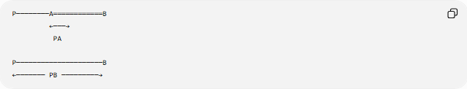
P────────A════════════B
←───→
PA

P─────────────────────B
←─────── PB ─────────→
- $PA$= external secant segment
- $AB$= internal chord segment
- $PB$= whole secant segment
The relationship is:
$$\boxed{PB=PA+AB}$$

Secant and Circle Chords
# Source: AI Source: Provided by: [Data Path: Persons Table -> ID Column: 1, Name_En Column: Motasem Essam] -> From: [ChatGPT] on [7/25/2026]
Every secant that intersects a circle at two points determines a chord.
If the intersection points are $A$and $B$, then:
$$\overset{‾}{AB}$$
is a chord.
However, not every chord is a secant because a chord is a segment, whereas a secant is a line.

Classification
# Source: AI Source: Provided by: [Data Path: Persons Table -> ID Column: 1, Name_En Column: Motasem Essam] -> From: [ChatGPT] on [7/25/2026]
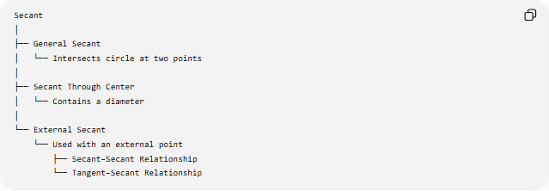
Secant
│
├── General Secant
│ └── Intersects circle at two points
│
├── Secant Through Center
│ └── Contains a diameter
│
└── External Secant
└── Used with an external point
├── Secant–Secant Relationship
└── Tangent–Secant Relationship

Secant vs Tangent vs Chord
# Source: AI Source: Provided by: [Data Path: Persons Table -> ID Column: 1, Name_En Column: Motasem Essam] -> From: [ChatGPT] on [7/25/2026]
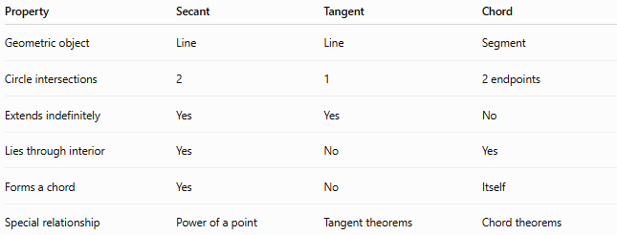
Property | Secant | Tangent | Chord
Geometric object | Line | Line | Segment
Circle intersections | 2 | 1 | 2 endpoints
Extends indefinitely | Yes | Yes | No
Lies through interior | Yes | No | Yes
Forms a chord | Yes | No | Itself
Special relationship | Power of a point | Tangent theorems | Chord theorems

Important Relationships
# Source: AI Source: Provided by: [Data Path: Persons Table -> ID Column: 1, Name_En Column: Motasem Essam] -> From: [ChatGPT] on [7/25/2026]
Secant–Secant
$$\boxed{PA⋅PB=PC⋅PD}$$
Tangent–Secant
$$\boxed{PT^{2}=PA⋅PB}$$
Secant Through Center
$$\boxed{\text{Chord}=\text{Diameter}}$$
External and Whole Secant
$$\boxed{PB=PA+AB}$$

Example
# Source: AI Source: Provided by: [Data Path: Persons Table -> ID Column: 1, Name_En Column: Motasem Essam] -> From: [ChatGPT] on [7/25/2026]
A secant from an external point $P$intersects a circle at $A$and $B$.
Suppose:
$$PA=5\text{ cm}$$
and:
$$AB=7\text{ cm}$$
Then the entire secant length is:
$$PB=PA+AB \\ PB=5+7 \\ \boxed{PB=12\text{ cm}}$$

Real-World Applications
# Source: AI Source: Provided by: [Data Path: Persons Table -> ID Column: 1, Name_En Column: Motasem Essam] -> From: [ChatGPT] on [7/25/2026]
Secant geometry is useful in:
- Computer graphics
- CAD and geometric modeling
- Engineering design
- Circular structures
- Optical systems
- Mechanical design
- Surveying
- Construction geometry
- Computational geometry

Key Points
# Source: AI Source: Provided by: [Data Path: Persons Table -> ID Column: 1, Name_En Column: Motasem Essam] -> From: [ChatGPT] on [7/25/2026]
- A Secant is a line that intersects a circle at two distinct points.
- The two intersection points determine a chord.
- The chord is only the segment inside the circle.
- A secant passing through the center contains a diameter.
- From an external point, two secants satisfy:
$$\boxed{PA⋅PB=PC⋅PD}$$
- A tangent and secant from the same external point satisfy:
$$\boxed{PT^{2}=PA⋅PB}$$
- A tangent intersects the circle once, while a secant intersects it twice.

Conclusion
# Source: AI Source: Provided by: [Data Path: Persons Table -> ID Column: 1, Name_En Column: Motasem Essam] -> From: [ChatGPT] on [7/25/2026]
A Secant is a line that passes through a circle and intersects it at two distinct points. The portion between those intersection points is a chord, while the complete line is the secant. Secants are fundamental to circle geometry and are closely connected with chords, tangents, diameters, power of a point, and secant–secant and tangent–secant theorems.

